5.103: Without buoyancy, 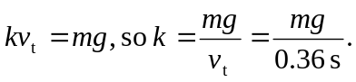
With buoyancy included there is the additional upward buoyancy force B, so
